Casey Irwin
M3: B – Decision Making
3/19/2019
Where to live in Pittsburgh?
I had been living in the Strip District in Pittsburgh for a year and decided to weigh my options of where to sign my next apartment lease at. There were 3 main options that I was looking at which were stay in the Strip District, move to Mount Washington or move to Robinson.
Strip District – I enjoyed my year lease living in an apartment complex in a good location. Central to everything and provided a nice running path along the river to the point. The area is being invested in currently and new apartment complexes and stores are popping up. Younger area with the apartment complexes for meeting new people
Mount Washington – Great views of the city of Pittsburgh. Do not have to live in an apartment complex but rather can rent a house. Easy access to 376 and a short drive into the city. Older neighborhood so housing is a little bit older. Tight narrow streets with parking.
Robinson – Surrounded by a major shopping area with mall, groceries, movie theaters, etc. Away from the city and closer to work. Not as much going on as in the city. Can look for either apartment complex or housing.
Decision Factors: cost, commute time to work, social aspect, parking, one or two bedroom place
The overall issue is living in a place that I still have a social aspect with a reasonable cost on a two bedroom place with a reasonable commute time to work. I would normally weigh my options based off of the most important decision factors to me. The most important factor is the cost of a two bedroom place as the Strip District would be very expensive to have a two bedroom place so that I can have a guest bedroom. I looked at the cost and decided the Strip District would only be able to do a one bedroom apartment. I also wanted to stay closer to the city so Robinson was a distant 3rd in this process as the sole reason to move out there is to have a closer commute to work. Mount Washington is an older neighborhood but checked the cost of a two bedroom place as reasonable, the commute time was still shorter to work from the Strip District but still 25-30 minutes (on a good day). I was able to still have a social life toward the city with uber/lyft being relatively cheap to drive to the city hot spots. Mount Washington also provided off street parking where I did not have to pay like the Strip District made you do. After looking at each of my highlighted decision factors, I decided that Mount Washington was my best spot to choose from and I decided to rent out a 2 bedroom house.

In order to lower my inconsistency model of 0.15118 for my Criteria 1 in the M2: C decision pairwise, I needed to adjust the following:
- Adjust 1.) Cost vs 3.) Social Life to a blue 6
- Adjust 1.) Cost vs 4.) Parking to a blue 9
- Adjust 1.) Cost vs 5.) Two Bedroom to a blue 8
- Adjust 2.) Commute vs 3.) Social Life to neutral 1
- Adjust 2.) Commute vs 4.) Parking to a blue 9
- Adjust 2.) Commute vs 5.) Two Bedroom to 2 blue
- Adjust 3.) Social Life vs 4.) Parking to blue 4
- Adjust 3.) Social Life vs 5.) Two Bedroom to Blue 2
- Adjust 4.) Parking vs 5.) Two Bedroom to red 3
This resulted in an inconsistency of 0.05506 which is in compliance with the <0.10
The AHP model overall provided the same result as the initial decision I made of moving to Mount Washington.
The ratings model priority output is listed below:
Overall, Mount Washington was again the decision based off of the rating model. After rating the Cost, Commute Time, Social Life, Parking Situation and Two bedroom from a criteria of:
- Excellent
- Above average
- Average
- Below average
- Poor
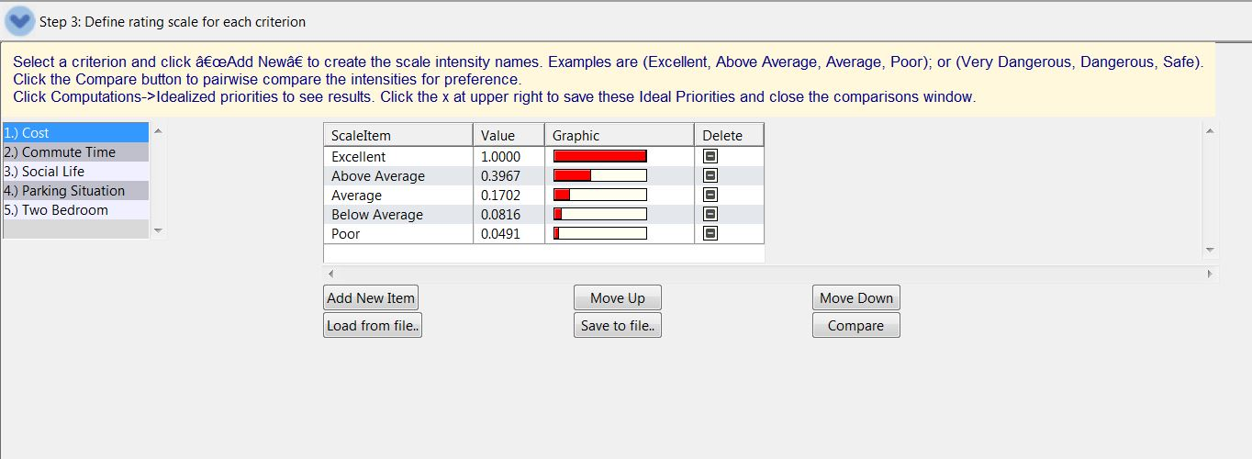
Overall the comparison between the two looks as follows:

